**Fire Technical Advisory Committee – Errata**

**8th Edition (2023) Florida Building Code, Building**

**CHAPTER 35 REFERENCED STANDARDS**

F-FBC- B-Ch. 35 – Errata #4 **(Received after deadline 11/28/2023)**

**From:** Soto, Rolando <ROSOTO@broward.org>   
**Sent:** Tuesday, November 28, 2023 11:27 AM  
**To:** Madani, Mo <Mo.Madani@myfloridalicense.com>  
**Cc:** Parks, Bryan <BParks@broward.org>  
**Subject:** FBC NFPA standard edition year typo.

|  |
| --- |
| **[NOTICE] This message comes from a system outside of DBPR. Please exercise caution when clicking on links and/or providing sensitive information. If you have concerns, please contact your Knowledge Champion or the DBPR Helpdesk.** |

Good morning, Mo,

The FBC Building is showing the year 2020 for NFPA 2001. That year does not exist. The FFPC is adopting the 2018 edition.

Respectfully,

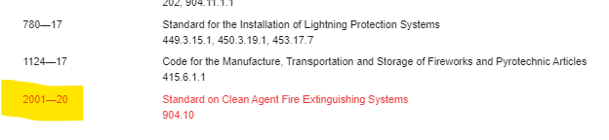

**TAC Recommendation**:

**Commission Action:**